How to submit an Aleph Enhancement Request

Before entering a new request, please evaluate the need for the request:
- Check the latest version that is available for you.
- Check the release notes for later Aleph versions on Ex Libris' Documentation Portal.
- Search the requests database for similar entries.
- Search in mailing lists for functionality in latest version available.

Submitting a NEW request

- Enhancement requests should be submitted online in http://ners.igelu.org website.

- First you should authenticate with your NERS username and password. If you don’t have one, please email ners@igelu.org and ask for your credentials.

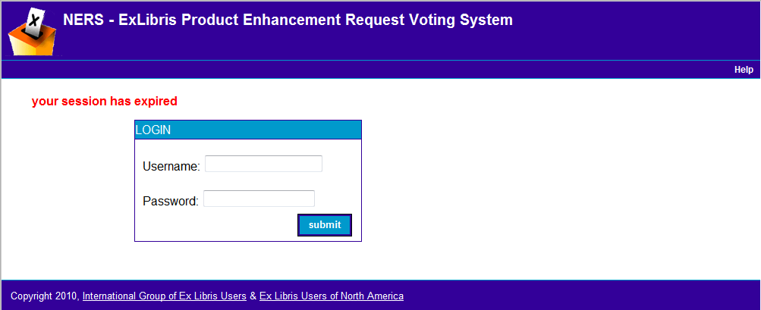

- After authentication you should select the option “Request” from the menu.

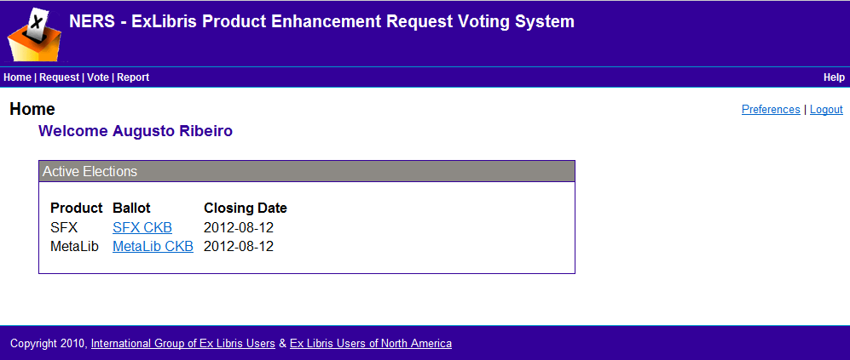

- Select the button “New Request” in the requests page.

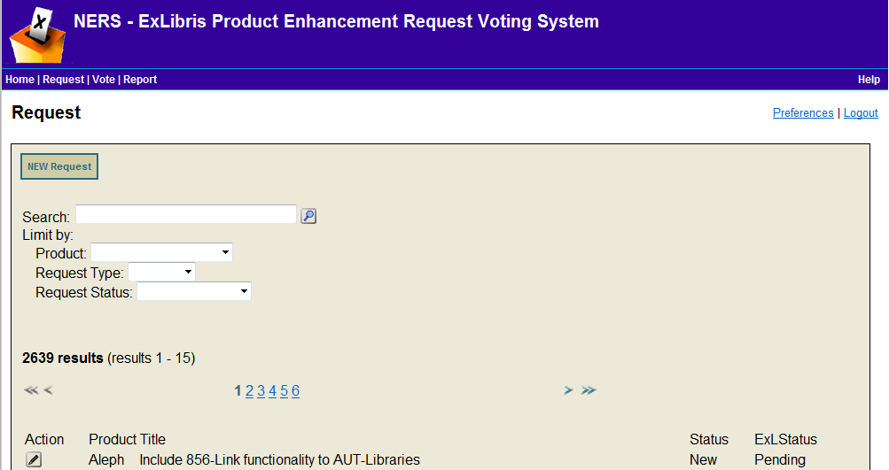

- When you fill the request make sure that you include detailed information about it.
  - Requester email
  - Request type
  - Requester Title
  - Description – Summarize the purpose of the enhancement
  - Keywords – use standard ALEPH terms
  - Product Module – Select ALEPH and then the ALEPH module
  - Product Version
  - System OS
  - Client OS
  - Notes
  - Private Notes
- Additionally, it’s very important that you also include in fields Notes or Private Notes the following information:
  - Explanation of why the enhancement is required.
  - Detailed description of enhancement.
This information is very important to makes work easier for module coordinators and for all users who review the request when voting.

For modification to the request after you have submitted it, please contact the ALEPH PWG (aleph@igelu.org)

